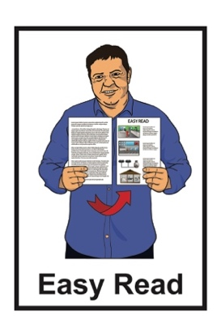
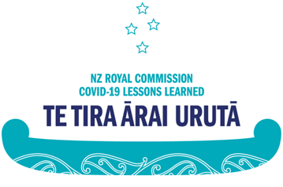
\

Lessons learned from
COVID-19:

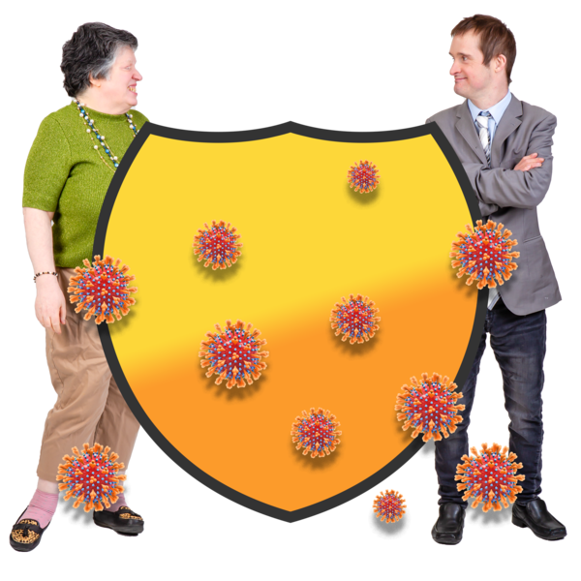
Phase 1 report
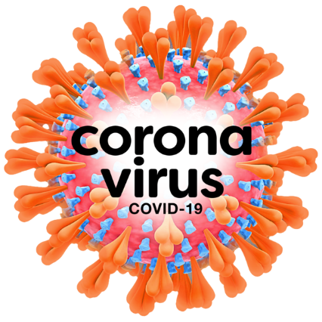

Published: December 2024

Before you start

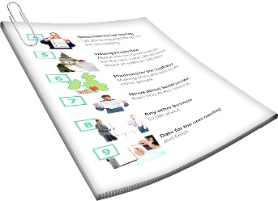
This is a long document.

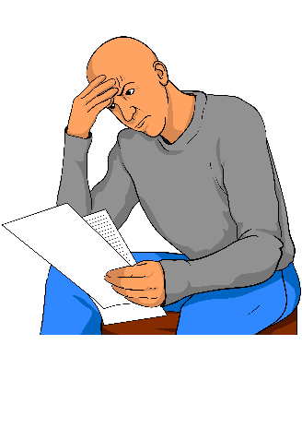
It can be hard for some people to read a document this long.

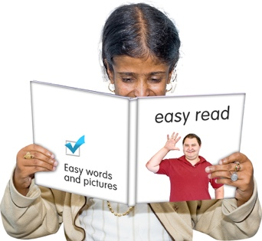
Some things you can do to make it easier are:
read it a few pages at a time
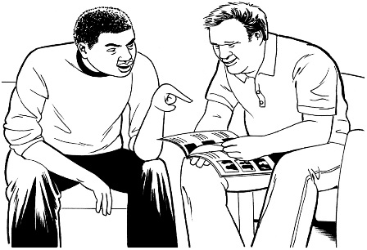
set aside some quiet time to look at it
have someone read it with you to support you to understand it.

What you will find in here

Page number:
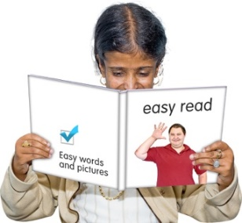

About this document 4

What is the Royal Commission? 6

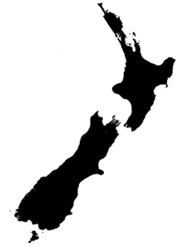
How did Aotearoa New Zealand
do during the pandemic? 13

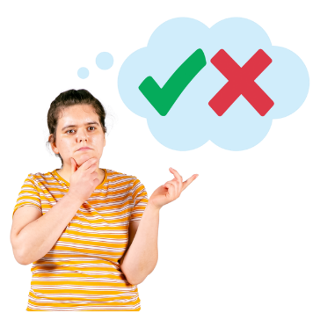
Being prepared and making good decisions 15

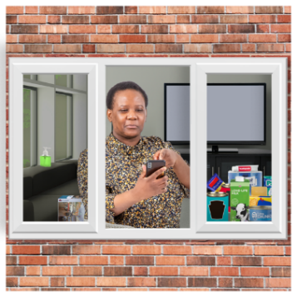
Lockdowns 17

Closing the borders 19
Page number:
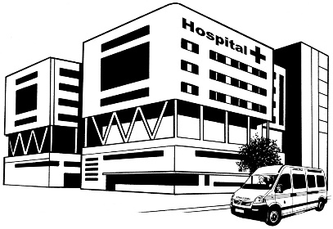

Healthcare in the pandemic 20
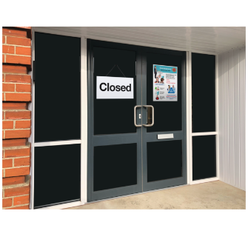

Social and economic changes 22

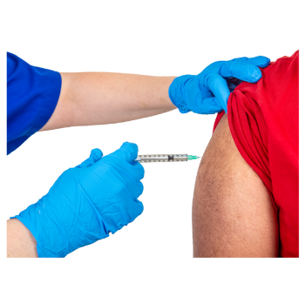
Vaccination 24

Mandates 27
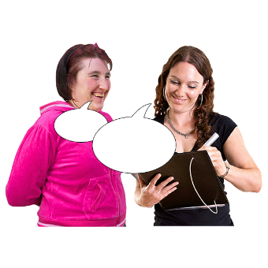

What did people tell the Royal Commission? 29


Getting ready for the future 35


What happens now? 40

About this document


This Easy Read is a summary of the Phase 1 / first report from
New Zealand Royal Commission COVID-19 Lessons Learned –
Te Tira Ārai Urutā.

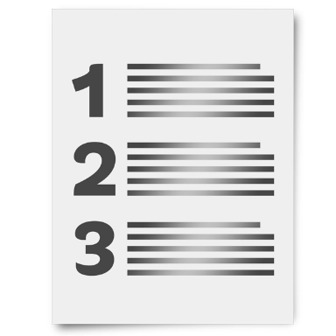
A summary:
is shorter than the main document
tells you the main ideas.

In this document New Zealand Royal Commission COVID-19 Lessons Learned – Te Tira Ārai Urutā will be called the Royal Commission.

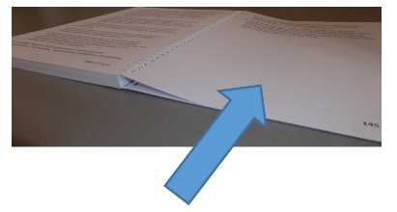
There is more information about the Royal Commission on pages 6 to 12.

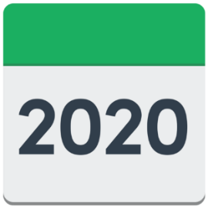
The COVID-19 pandemic came to Aotearoa New Zealand in 2020.

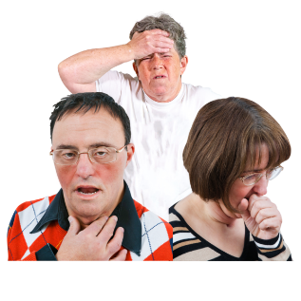
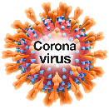
COVID-19 is a type of virus that makes people sick.

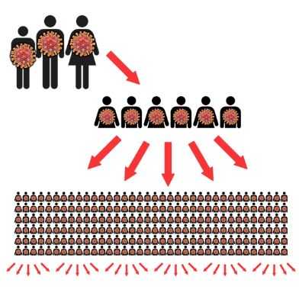
A pandemic is when many people around the world get the same sickness at the same time.

What is the Royal Commission?

The Royal Commission is a group of people who learned about things that happened during the COVID-19 pandemic.

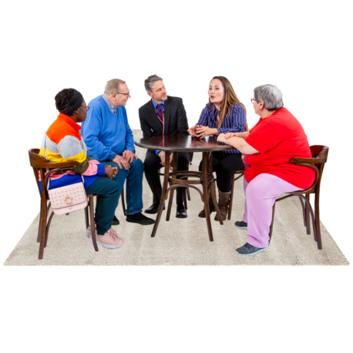
The Royal Commission:
held nearly 4 hundred meetings
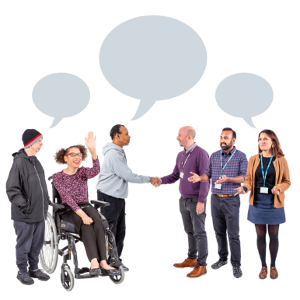
met with over 1 thousand 6 hundred people
met with nearly 2 hundred and 50 organisations
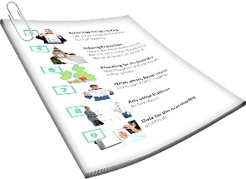
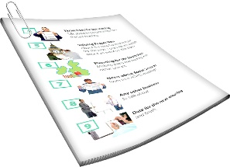
got over 1 hundred and 33 thousand pages of evidence
received nearly 13 thousand public submissions.

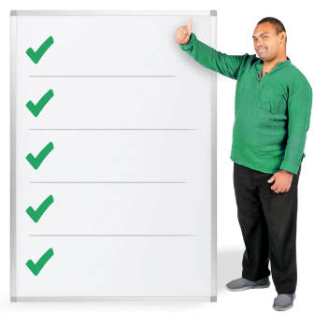
Evidence is facts about something that happened.

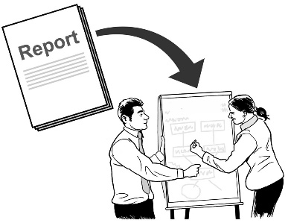
Here a submission is a kind of report someone writes so another person can use the information in it.


The Royal Commission spoke to people who made important decisions during the pandemic like former Prime Minister Jacinda Ardern.

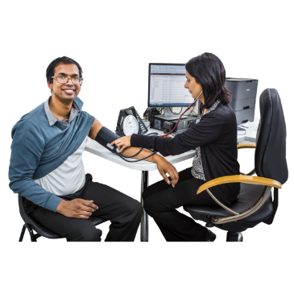
The Royal Commission spoke to:


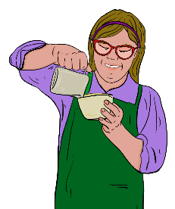
government agencies
healthcare providers
businesses.

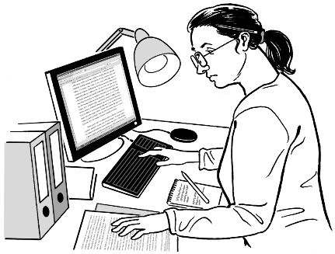
The Royal Commission read important things written about the pandemic like:
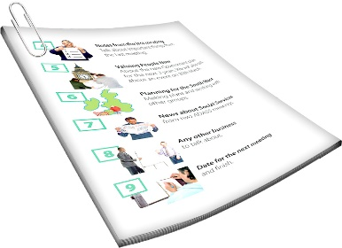
research papers
documents put out by the Government.

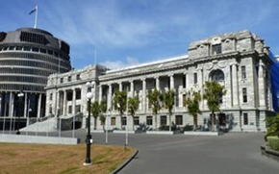
The Royal Commission looked at:
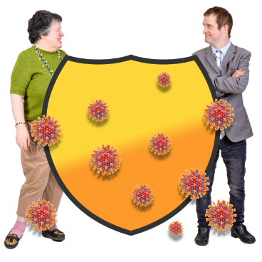
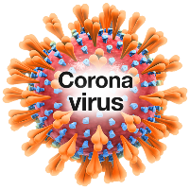
how the Government was ready for the pandemic
what the Government did to stop COVID-19
how different things were done like:
- lockdowns
- borders
- MIQ.
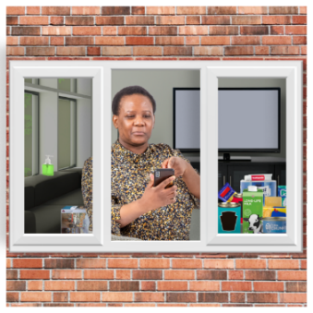
Lockdowns were when the Government asked everyone to stay at home so that they would not get sick or spread the virus.

Borders are where people:
come into the country
leave the country.

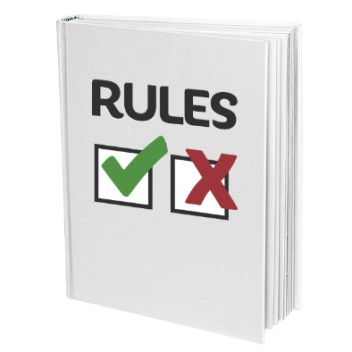
When the border was closed during the pandemic there were lots of rules about who could:
- come into Aotearoa New Zealand
- leave Aotearoa New Zealand.

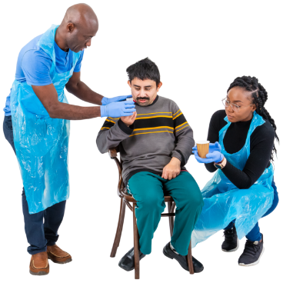
Managed Isolation and
Quarantine / MIQ was when people who came into the country were kept away from everyone else for a short time.
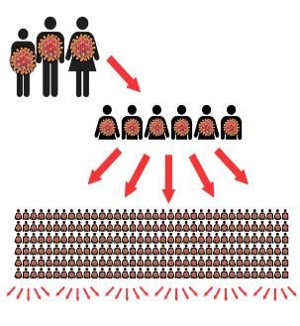

This was to check if they were sick with COVID-19 so the virus would not spread through the country.

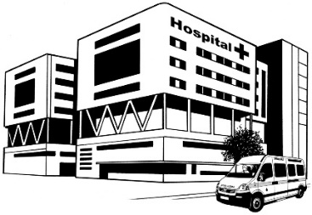
The Royal Commission also looked at:
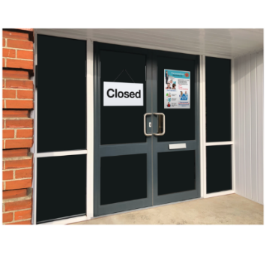
the health system
what happened to the economy
social impacts
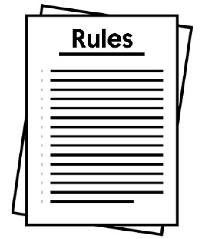
vaccines
mandates.

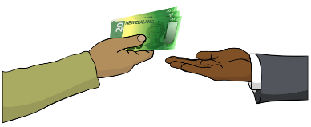
The economy is all the ways a country:
makes money
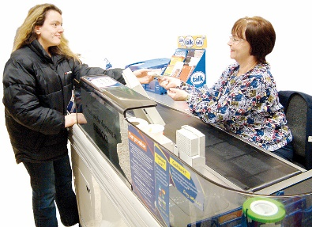
and
spends money.

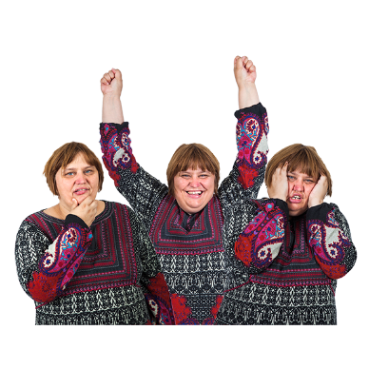
Here social impacts means:
how people felt during the pandemic
what people were able to do during the pandemic.

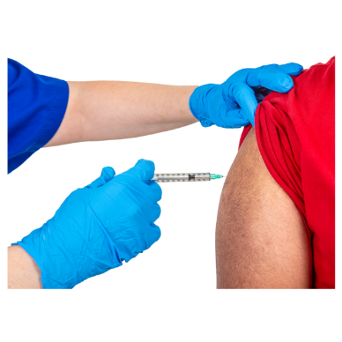
A vaccine is a medicine that can help stop you from getting very sick.

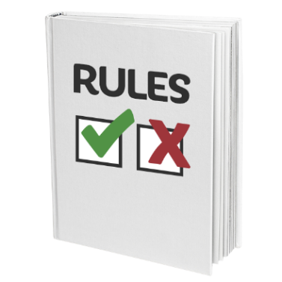
Here mandates mean rules the Government made about what people could do at different times during the pandemic.

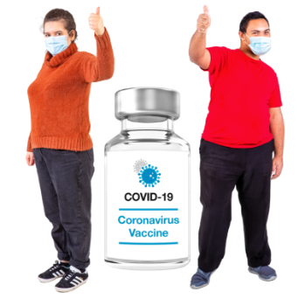
This was so people could keep safe from COVID-19.

This included rules like:
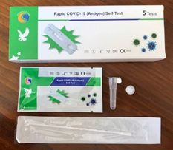
having to be vaccinated for some
things like doing your job
getting tested for COVID-19
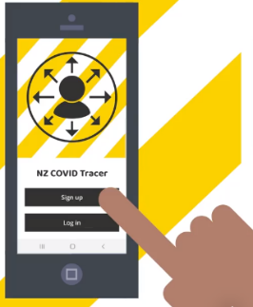
contact tracing which means listing:
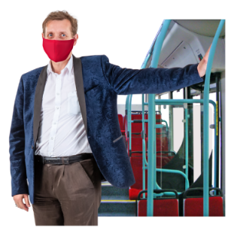
  - where you have been
  - the people you have spent time with
wearing a mask.

How did Aotearoa New Zealand do during the pandemic?

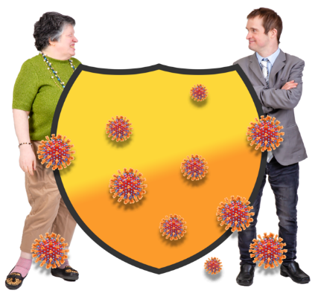
Aotearoa New Zealand did better than other countries at:
protecting people from COVID-19
keeping normal life going for as long as possible.

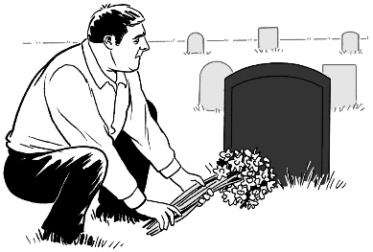
Aotearoa New Zealand also had:
fewer deaths from COVID-19
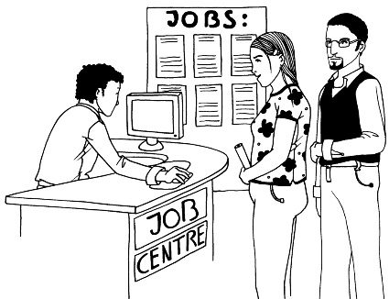
less time in lockdown
fewer people without jobs
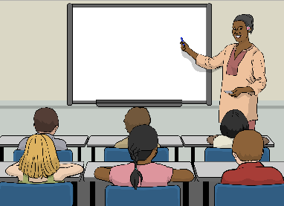
fewer days that
learners / students missed school.

These things were a success because everyone worked:
hard
quickly.

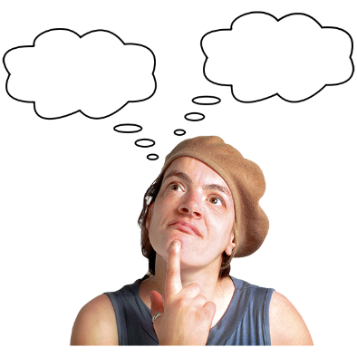


Our response was not perfect because we were not as ready as we should have been for a pandemic.

Being prepared and making good decisions

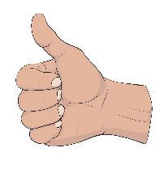
The Government did well at the start of the pandemic.

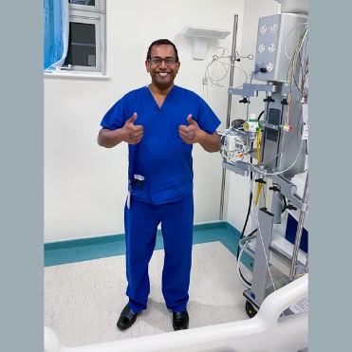
People in Government worked very hard to respond quickly to COVID-19.

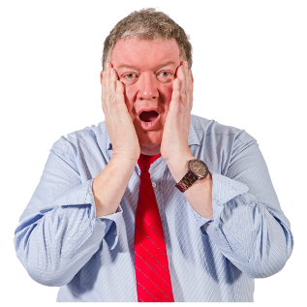
Aotearoa New Zealand was not ready for how big the pandemic got.

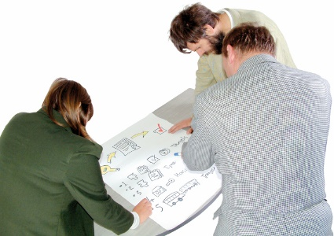
We changed how we did things to keep up with what was going on.

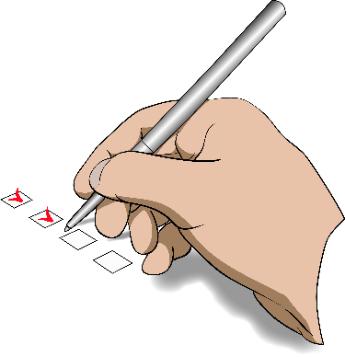
The Royal Commission found the Government needed to be better prepared to support the country as the pandemic kept going.



The Royal Commission found the Government needed to work more with:
businesses
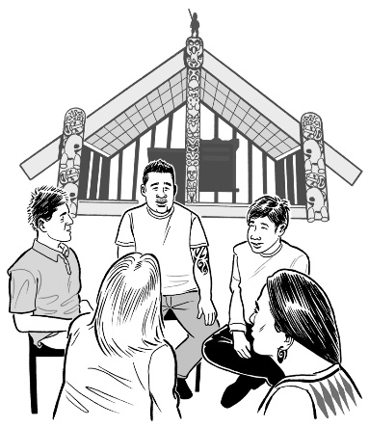
iwi / Māori tribes
communities.

Lockdowns


The Royal Commission found lockdowns kept COVID-19 from being spread at the start of the pandemic.

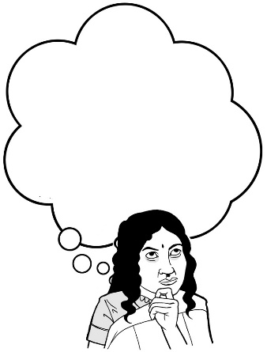
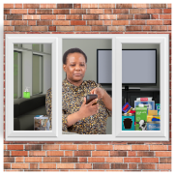

The Royal Commission found lockdowns were hard:
to put in place / make happen
to keep going well
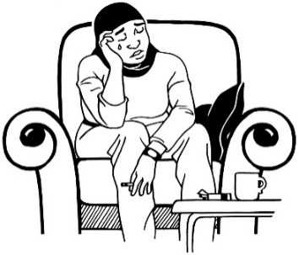
on some people more than others.

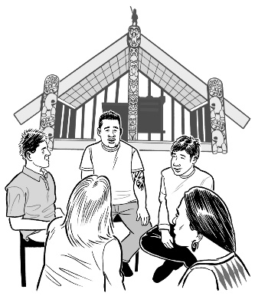
The Royal Commission found some groups were very important in supporting people during lockdowns like:
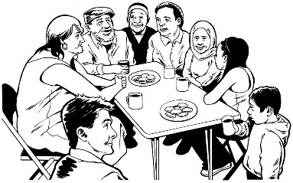
iwi / Māori tribes
community groups.

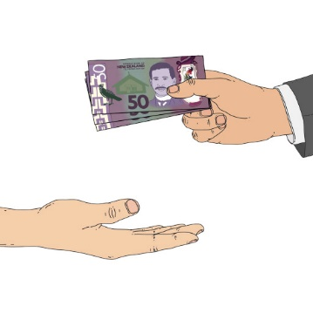
The Royal Commission said a way to have fewer lockdowns if another pandemic happens is to support public health with more:
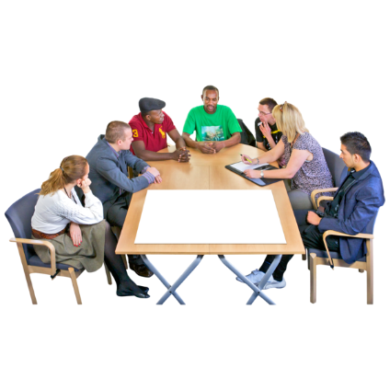
money
people to do the work.

Closing the borders


The Royal Commission found that closing the borders kept COVID-19 out of Aotearoa New Zealand.

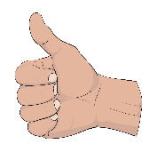
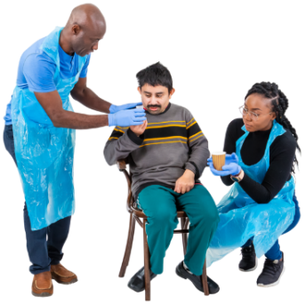
The Royal Commission says setting up Managed Isolation and Quarantine / MIQ so fast was a big achievement.

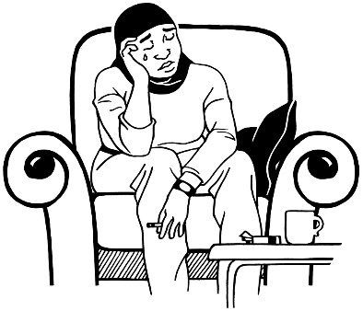
The Royal Commission found closing the borders was very hard on some people.


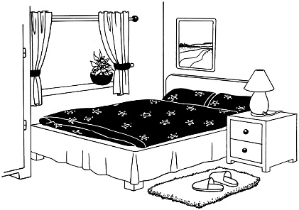
The Royal Commission found there were many problems with MIQ like not having enough rooms for everyone who wanted to travel to Aotearoa New Zealand.

Healthcare in the pandemic

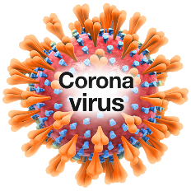
The Royal Commission found the Aotearoa New Zealand healthcare system was not ready for a pandemic.

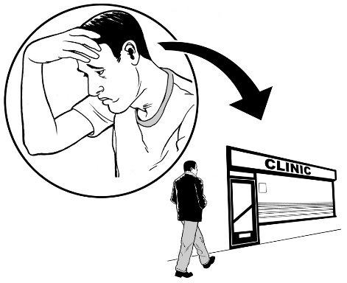
The pandemic was a very difficult time for healthcare:
workers
providers.


What the Government did during the pandemic was good at stopping the healthcare system from being overwhelmed.

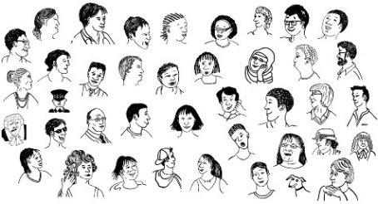
Here overwhelmed means:
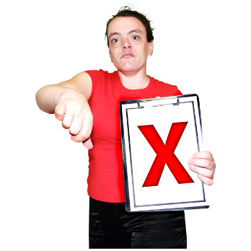
too many people are using something all at once
there is not enough for everyone.

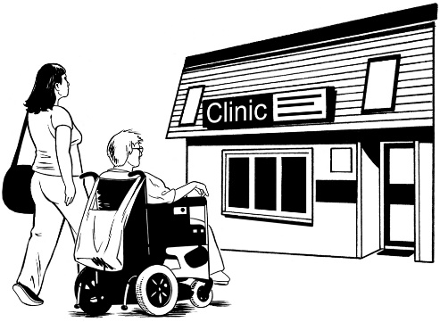
There were big problems like people could not:

visit their loved ones in hospital
get their usual healthcare.
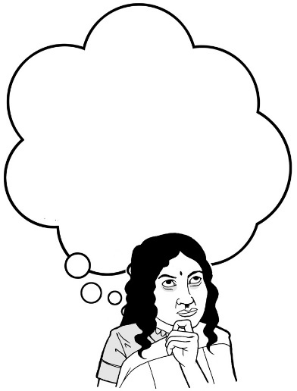

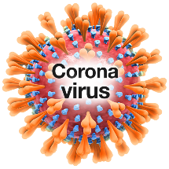

The Royal Commission found that problems in the healthcare system were made worse by the pandemic.

Social and economic changes

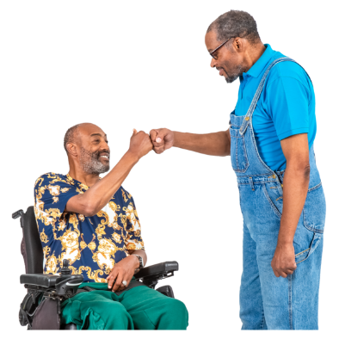
The Royal Commission found that during the pandemic the Government had given good:
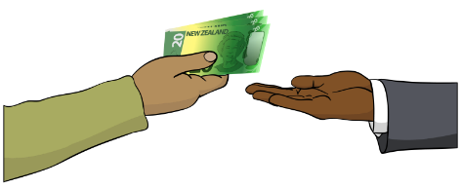
social support that made sure people were looked after
economic support that made sure:
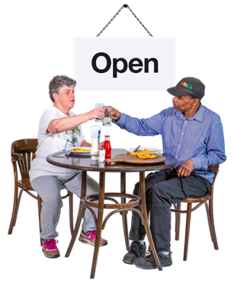
- businesses could still run
- most people had enough money to live.

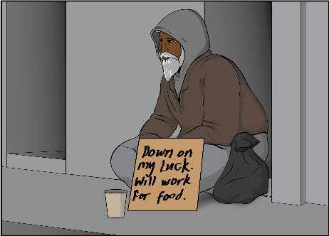
The pandemic made some things in Aotearoa New Zealand worse like:
social problems like people not having a place to live
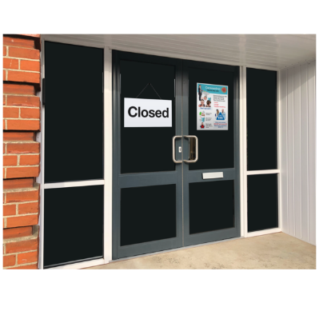
economic problems like businesses not being able to run properly.

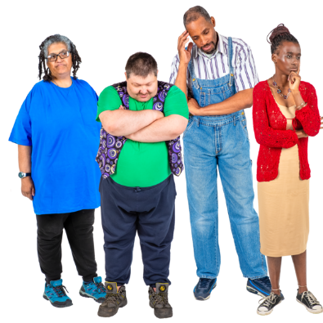
The Royal Commission found that the pandemic was worse for some people than for others.

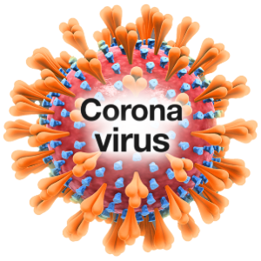
The Royal Commission found that:
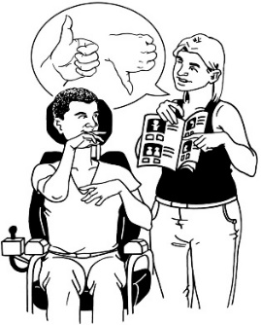
the COVID-19 pandemic is not over for many people
people still need support.

Vaccination

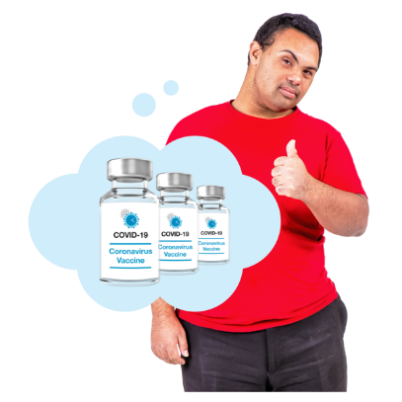
The Royal Commission found that getting a vaccine for Aotearoa New Zealand was done the right way.

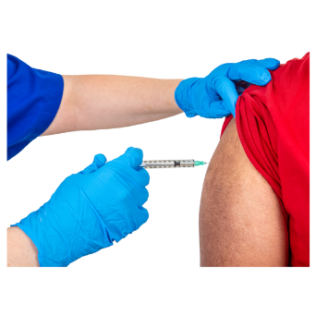
Getting the vaccine to everyone:

was hard
went mostly well.

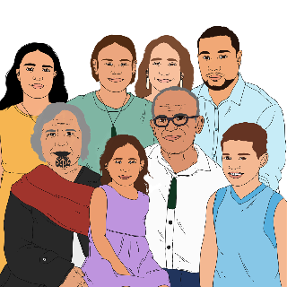
The Royal Commission found it took too long to get the vaccine to:
Māori
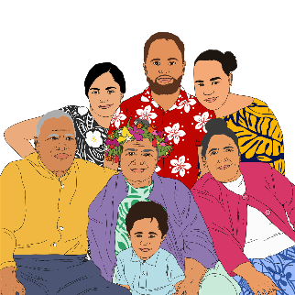
Pacific people.

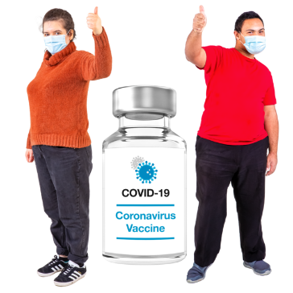
The Royal Commission found that getting people vaccinated:
saved more than 6 and a half thousand lives
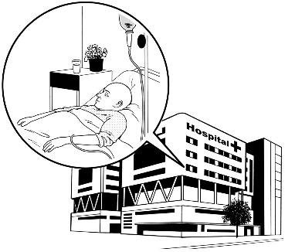
stopped more than 45 thousand people having to go to hospital when sick.

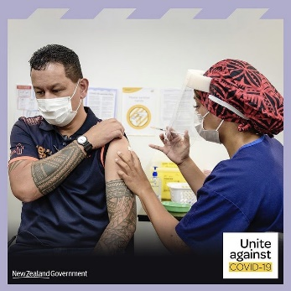
It was a big job to get the vaccine out to everyone in Aotearoa New Zealand.

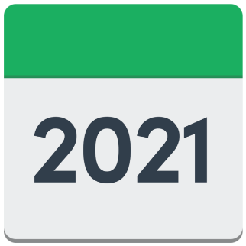
Most people had 2 doses of the vaccine by the end of 2021.

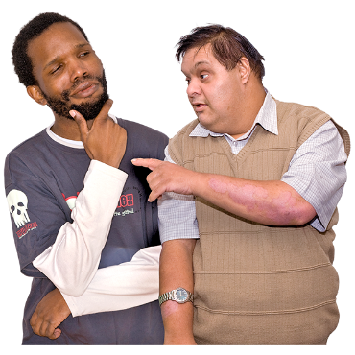
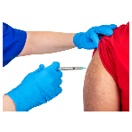
Some people:

were not sure about getting vaccinated
found it hard to get the vaccine
did not want the vaccine.

Mandates

During different parts of the pandemic the Government said people must:
get tested for COVID-19
do contact tracing / say if they went to a place where there were lots of other people
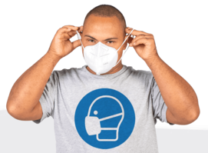
wear a mask
get vaccinated for things like doing their job.

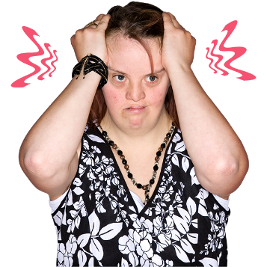
The Royal Commission found that mandates made some people very unhappy with the Government.

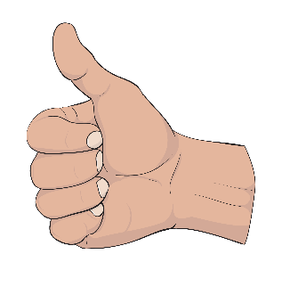
The Royal Commission found that mandates:
were a good thing to do
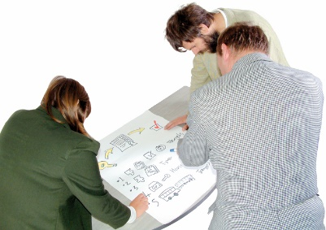
but
could be done better if another pandemic happens.
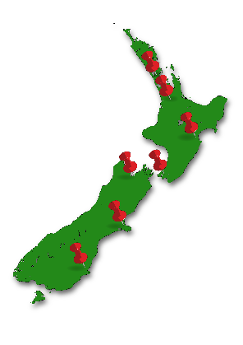
The Royal Commission found that it upset a lot of people when some vaccine mandates were used:
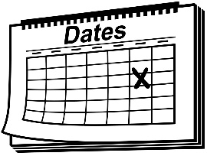
in too many places
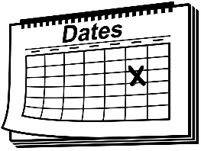
for too long.

What did people tell the Royal Commission?

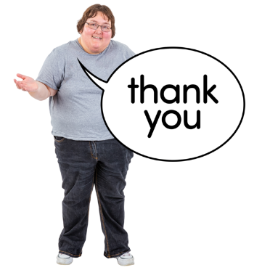
The Royal Commission thanks everyone who shared what happened to them doing the COVID-19 pandemic.

People told the Royal Commission:
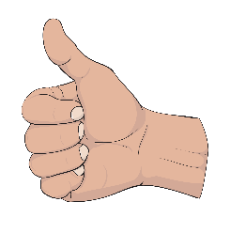
Aotearoa New Zealand did well at the start of the pandemic
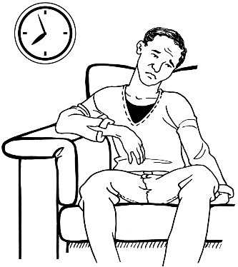
many people became unhappy as the pandemic kept going.

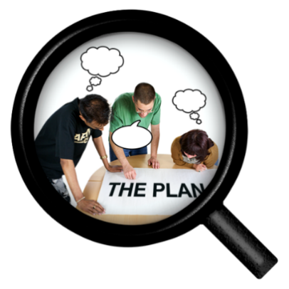
People told the Royal Commission:
Aotearoa New Zealand needed to be better prepared for the pandemic
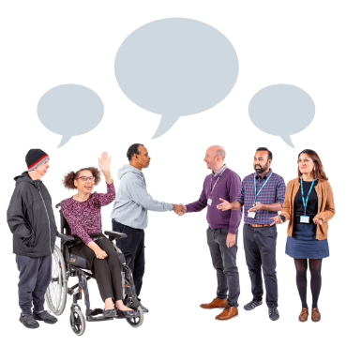
and
the whole Government needed to work together.

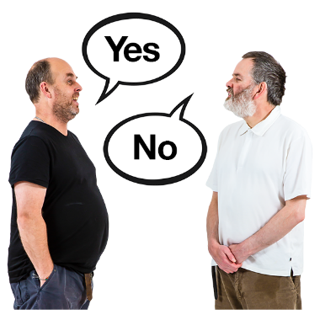
The Royal Commission heard that:
people did not agree on whether lockdowns were a good thing
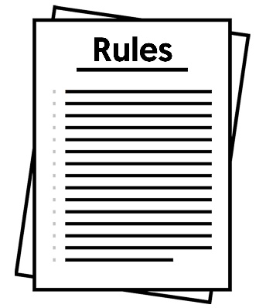
lockdowns could have easier rules to follow
lockdowns should only be used when it is very important.

People told the Royal Commission:
the borders of the country should have been closed sooner
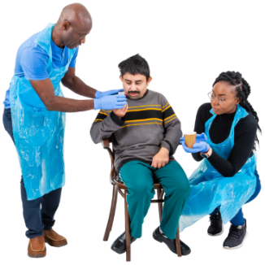
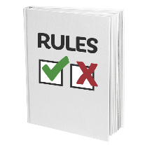
MIQ should have:
- been more fair
- had better rules
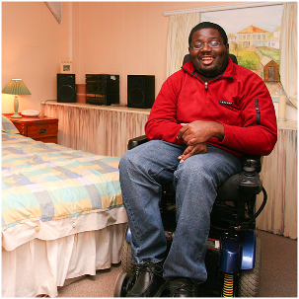
people should have been able to isolate / do quarantine at home.

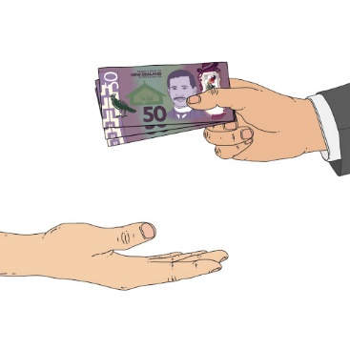
The Royal Commission heard that the Government needs to put more money into the healthcare system.

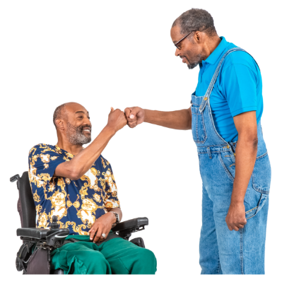
The Royal Commission heard that people:
in general felt supported during the difficult times of the pandemic
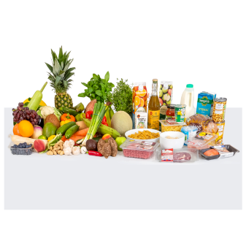
but

still felt the impacts like:

- prices going up like food costing more
- people not getting along very well.

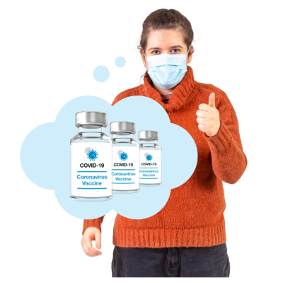
The Royal Commission heard that:
people were happy that vaccines were available
but
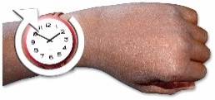
getting vaccines to everyone could have been done quicker.


Some people said they did not have enough information to give informed consent for the vaccine.

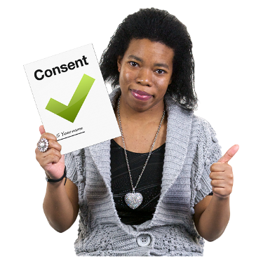
Consent is when you agree to do something.

It is your choice to give consent.


Informed consent is when you have the information you need to make your choice.

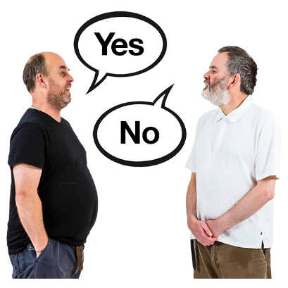
People could not agree if mandates:
were a good thing
should be used again if another pandemic happens.

Getting ready for the future

The Royal Commission says we need to make sure everyone can work together during a pandemic including:
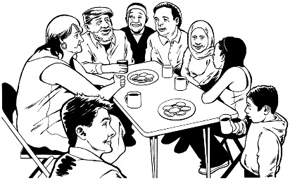
the Government
communities around the country.

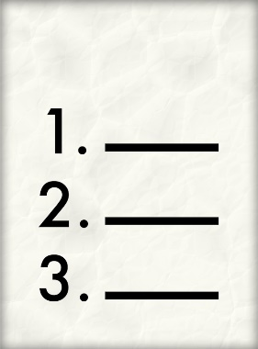
The Royal Commission has made recommendations to the Government so they will be ready if another pandemic happens.

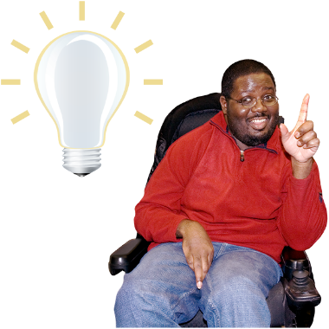
A recommendation is an idea that would be a good thing to do.

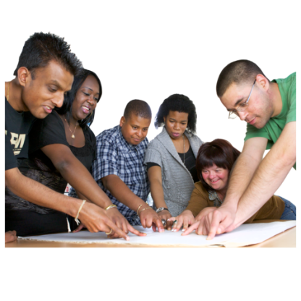
The Royal Commission recommends the Government makes a pandemic plan where all agencies work together.

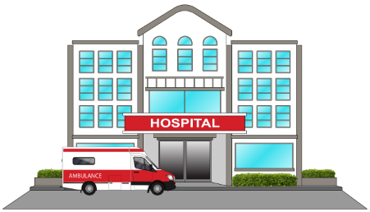
The Royal Commission recommends all parts of the country are ready for a pandemic including:
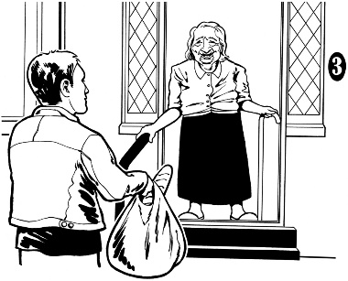
health
social
economic
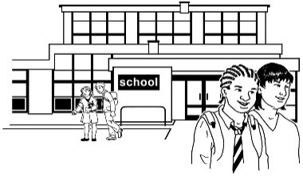
education like schools
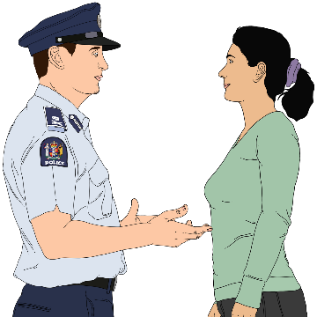
justice like:
- the police
- courts.

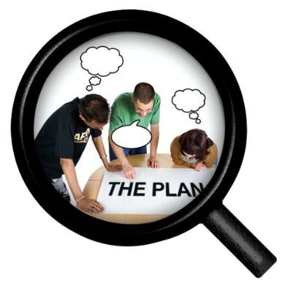
The Royal Commission recommends the Government sets up a group to organise everyone in Government to get ready for pandemics in the future.

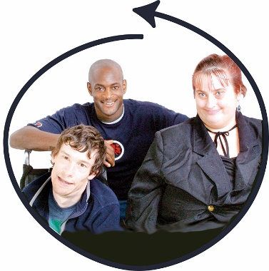
The Royal Commission recommends that in a future pandemic response the Government should:
be focused on people
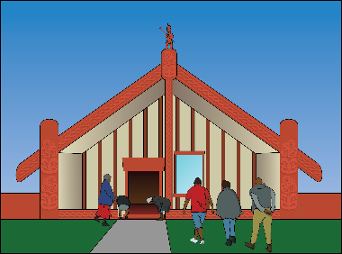
work closely with communities in Aotearoa New Zealand.

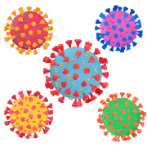
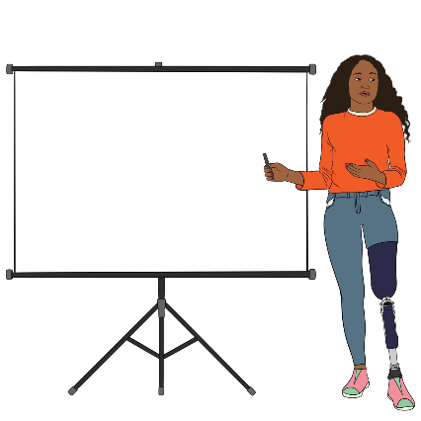
The Royal Commission recommends the Government use experts to support their pandemic:
planning
response.

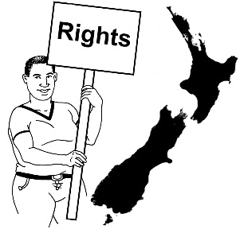
Using experts for pandemic planning will support the Government to:
protect human rights / the things everyone should be able to do
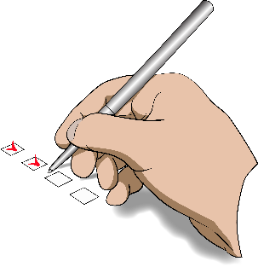
focus on outcomes that will happen over a long time.

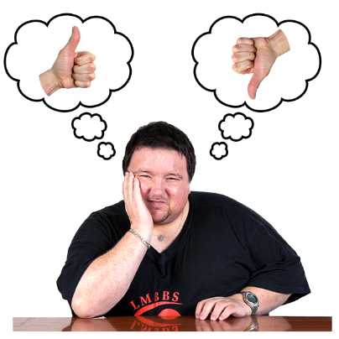
Outcomes are how things end up for people.

Here an outcome could be everyone having access to vaccines.

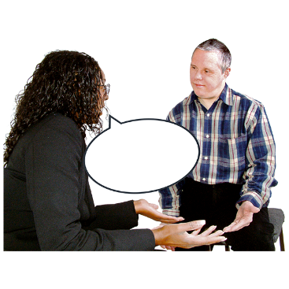
The Royal Commission recommends that if a pandemic happens in the future the Government:
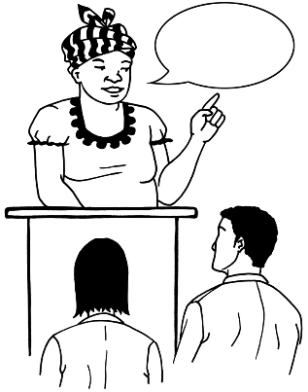

listens to concerns from everyone
is clear about its decisions.

What happens now?

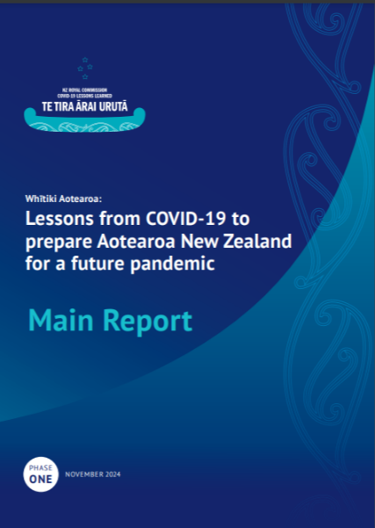
This is an Easy Read summary of the full report called:

Lessons from COVID-19 to prepare Aotearoa New Zealand for a future pandemic.

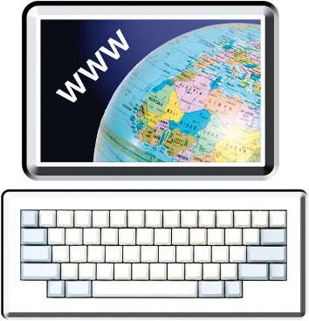
You can find the full report on the Royal Commission website at:

www.covid19lessons.royalcommission.nz/reports-lessons-learned/
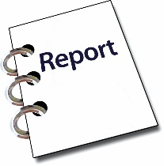
1
The Royal Commission has given this report to the Government.

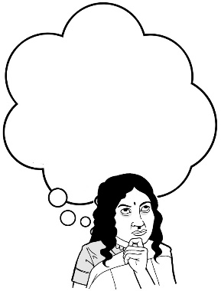
The Government:
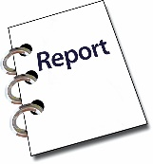
is thinking about the recommendations
1
will decide what it wants to do to get ready for a pandemic in the future.

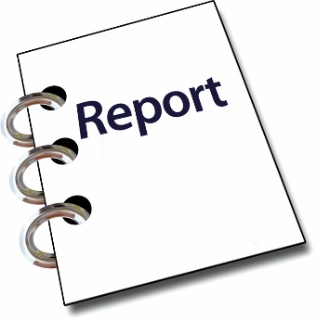
A Phase 2 / second report of the COVID-19 Inquiry:
2
is being written
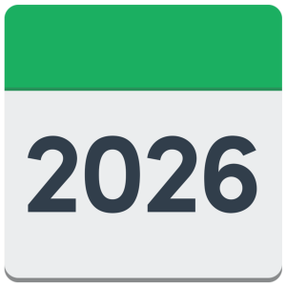
and
will go to the Government in 2026.

You can find out more about New Zealand Royal Commission COVID-19 Lessons Learned – Te Tira Ārai Urutā at this website:

www.covid19lessons.royalcommission.nz

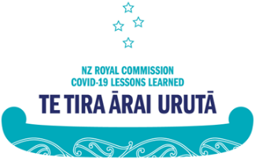
This information has been written by New Zealand Royal Commission COVID-19 Lessons Learned – Te Tira Ārai Urutā.

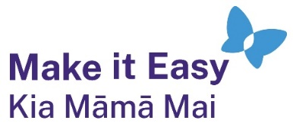
It has been translated into Easy Read by the Make it Easy Kia Māmā Mai service of People First New Zealand Ngā Tāngata Tuatahi.

The ideas in this document are not the ideas of People First New Zealand Ngā Tāngata Tuatahi.
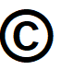
All images used in this Easy Read document are subject to copyright rules and cannot be used without permission.


Make it Easy uses images from:

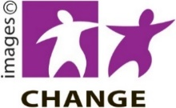
- Photosymbols

- Change Images


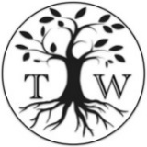
- Huriana Kopeke-Te Aho

- SGC Image Works

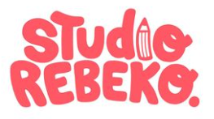
- T. Wood

- Studio Rebeko.

