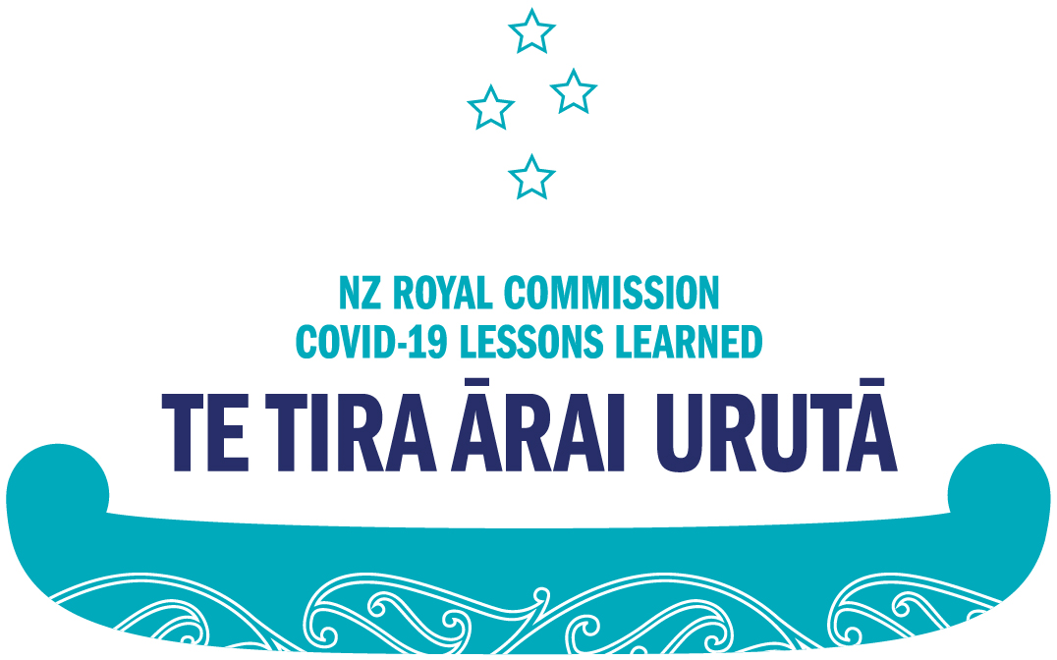

Whītiki Aotearoa | Be Ready New Zealand: Lessons from COVID-19 to prepare Aotearoa New Zealand for a future pandemic

Introduction
In February 2023, we asked you to share your experience of COVID-19 to help us learn from Aotearoa New Zealand’s response to COVID-19 and plan for the future. We’d now like to share with you what the first phase of the COVID-19 Inquiry has learned about the pandemic and our country’s response to it.
We were asked to learn from Aotearoa New Zealand’s response to COVID-19 to get prepared for any pandemics that might happen in the future. As well as asking for your experiences, we also met with key decision-makers, like former Prime Minister Jacinda Ardern, and spoke with people and organisations, including Government agencies, healthcare providers, and businesses, from across Aotearoa about their experiences during COVID-19. We also received written evidence about the pandemic, like research papers and documents published by the Government.
The first phase of the Inquiry:
- Held nearly 400 meetings;
- Meet with over 1600 individuals and nearly 250 organisations;
- Gathered over 133,000 pages of evidence;
- Received nearly 13,000 public submissions.
We looked at key areas of Aotearoa’s response to the pandemic, like lockdowns, vaccine mandates, and MIQ. We found out how people took care of their health, paid their bills, got food, or kept up with their education. We heard about how the Government communicated with people about COVID-19 and how they made decisions.

We looked at:
- Government pandemic preparation;
- The Government’s COVID-19 elimination strategy;
- Lockdowns;
- Borders and quarantine;
- The health system;
- Economic impacts;
- Social impacts;
- Vaccination;
- Mandates.

Looking back at the COVID-19 pandemic
We looked back at the impact the pandemic had on Aotearoa New Zealand and how the Government responded to COVID-19.
Compared to other countries, Aotearoa New Zealand did very well at protecting people from the virus and addressing the impacts of a pandemic, especially in the early stages of the response. We had fewer COVID-19 deaths than almost any other OECD country, and overall we spent less time in lockdown than many other countries. Our unemployment rate stayed low, and learners missed fewer days of school than in most comparable countries. The rapid response and hard work of individuals, the public service, organisations, and communities everywhere was crucial to achieving these successes.
Aotearoa, like countries everywhere, was caught off-guard by the COVID-19 pandemic. We weren’t prepared for a pandemic like this one, and we faced many challenges along the way. The response was not perfect, and there are many things that could have been done better, and that we as a country could improve on in case of a future pandemic.

Being prepared and making good decisions
Like many other countries, Aotearoa wasn’t ready to face a pandemic like COVID-19. The Government had many of the tools they needed to respond well at the start, but better preparation would have helped us keep going throughout the pandemic.
The Government made hard decisions in the face of a lot of unknowns and communicated well at the start of the pandemic, but better arrangements could have helped as time went on.
- Aotearoa wasn’t ready for the scale of COVID-19, but we did adjust to meet the challenge.
- The Government started with a clear strategy but could have done better as the pandemic went on.
- The Government needed to work with businesses, iwi and communities more.
- Dedicated people across Government worked incredibly hard to respond quickly to COVID-19 – across multiple agencies, at our borders, in our health sector, in our quarantine facilities and in our communities.

Lockdowns
Lockdowns helped at the beginning of the pandemic, although there were some challenges getting them in place and they were very hard on some people. If we have better public health tools, like contact tracing, we may not need to use lockdowns as much in a future pandemic.
- Lockdowns helped keep COVID-19 out at the beginning.
- There were challenges in putting in place and managing lockdowns.
- Lockdowns were much harder on some people than others.
- Iwi and community groups were vital in supporting people during lockdowns.
- If we put more money and time into other public health measures (like contact tracing) we might not need so many lockdowns next time.

Closing the borders
Closing the borders was very helpful in keeping COVID-19 out of Aotearoa New Zealand, although it was hard on many people. Some of the challenges included a lack of spaces in MIQ facilities, which meant that many New Zealanders couldn’t travel to New Zealand when they wanted to.
- Closing the borders helped keep COVID-19 out.
- Border closures were hard on many people.
- There were many challenges in setting up and managing MIQ – like not always having enough rooms for everyone who wanted to travel to New Zealand.
- Setting up MIQ so fast was a huge achievement.

Healthcare in the pandemic
The healthcare system wasn’t ready for a pandemic, and the pandemic put a lot of strain on healthcare workers and providers. The Government’s actions successfully stopped the healthcare system from being completely overwhelmed by COVID-19, but people’s access to normal healthcare was disrupted more than it should have been as a result.
- The healthcare system was not ready for a pandemic.
- The Government’s actions successfully stopped the healthcare system from being overwhelmed.
- There were significant costs to these actions, like people not being able to visit loved ones in hospital.
- Regular healthcare was disrupted more than necessary.
- The pandemic made existing problems in the healthcare system much worse.

Social changes and economic changes
The Government’s response did help prevent deaths and protect people. However, the pandemic impacted some people far more than others, like those who lost jobs or went without the support they needed.
- The Government provided a lot of effective social and economic support.
- The pandemic made some existing social and economic problems worse.
- The pandemic was worse for some people more than others.
- COVID-19 is not over for many people, and they still need support.

Vaccination
In general, the process for getting and approving a vaccine for Aotearoa New Zealand was appropriate. The vaccine rollout was challenging but successful overall, although it took too long to reach many Māori and Pacific people.
We found that:
- Vaccination saved more than 6500 lives and prevented more than 45,000 hospitalisations.
- The process for getting and approving a vaccine was appropriate.
- An enormous effort went into the vaccine roll-out and most people had received two vaccine doses by the end of 2021.
- It took too long for some vulnerable groups to get their vaccines, in part because the vaccine rollout was late to involve Māori and Pacific health providers.
- Some people were hesitant to get vaccinated, found it hard to access, or did not want to, for a range of reasons.

Mandates
The Government mandated COVID-19 testing, contact tracing, masking, and vaccination under particular circumstances and at certain points during the pandemic. Many of these mandates were reasonable, but there were some issues in applying them. Mandates were one of the most controversial parts of the Government’s response to COVID-19.
- Mandates were challenging and some caused tension.
- Testing, contact tracing, and masking mandates were reasonable, but their implementation could be improved in a future pandemic.
- It was reasonable to introduce some vaccine mandates based on the information available in 2021.
- Some workplace, occupational and other vaccine requirements were applied too broadly and remained in place for too long, which caused harm to individuals and families and contributed to social divisions.

What we heard from you
Thank you to everyone who shared their COVID-19 pandemic experiences with us. Your experiences, alongside the meetings we held and the evidence we gathered, helped us assess Aotearoa New Zealand’s pandemic response, inform our findings, and make recommendations for the future. We wanted to share a summary of what you told us about your experiences of COVID-19.
Here is what we heard:
- Aotearoa New Zealand did well at the start, but many people lost confidence as time went on.
- Aotearoa New Zealand needed to be better prepared and the whole Government needed to work together.
- People were very divided on whether lockdowns were a good thing.
- Lockdowns should be more flexible and only used in extreme circumstances.
- The Government should close the borders faster.
- Home isolation should be allowed.
- MIQ should be more flexible and fair.
- Urgent healthcare like cancer screenings should always continue.
- The Government needs to invest more in the healthcare system.
- People generally felt supported when it came to economic and social challenges.
- People still felt the impacts of the pandemic, like rising costs and social divisions.
- People said they were grateful for access to vaccines, although they also felt the rollout could have been faster.
- Some people felt they did not have enough information to give informed consent for the vaccine.
- People were very divided on whether mandates were a good thing and if they should be used again.

Moving forward and preparing for the future
We don’t know when the next pandemic will happen, or what it will look like, but there are still steps we can take as a country to get ready and get through the next pandemic when it arrives.
We need to start building a strong pandemic response now. We need to make sure every part of Aotearoa New Zealand is ready, and make sure that the Government and communities throughout the country can work together when the next pandemic arrives.
We have made recommendations to the Government about what they should do now to prepare for any pandemics in the future and what they could do next time to get us through. Our recommendations are:
- Create a pandemic plan where all Government agencies work together.
- Make sure the health, social, economic, education, and justice sectors are ready to face future pandemics and to come out the other side.
- Create a group within a central government agency to coordinate government preparation for pandemics.
- Make sure our pandemic response is people-centred – working closely with communities and organisations throughout Aotearoa.
- Involve experts in pandemic planning and responses who will protect human rights and help focus on long-term outcomes.
- During future pandemics, ensure the Government listens to concerns from around the country and be clear about the reasons behind their decisions.

What happens now?
Our report is with the Government. The Government are considering our recommendations and will decide how they can use what we found to prepare for the future.
Phase Two of the COVID-19 Inquiry will also produce another report on some additional topics, like vaccine safety, which will go to the Government in 2026.
Thank you to you, and to every single person who made this Inquiry possible.
End of information: Whītiki Aotearoa | Be Ready New Zealand: Lessons from COVID-19 to prepare Aotearoa New Zealand for a future pandemic
This Large Print document is adapted by Blind Citizens NZ from the standard document provided by the Royal Commission of Inquiry into COVID-19 Lessons Learned

